Dustbowl Legacies: long term change and resilience in the Shortgrass Steppe

Kenneth M. Sylvester

Myron P. Gutmann

University of Michigan

This is a draft. Please do not cite without the permission of the authors.

Contact Information: Kenneth Sylvester, Inter-university Consortium for Political and Social Research, University of Michigan, PO Box 1248, Ann Arbor, MI 48106-1248. email: kenms@icpsr.umich.edu

This research has been supported by Grant Number BCS-0216560 from the National Science Foundation to Arizona State University, and by Grant Number HD33554 from the National Institute of Child Health and Human Development. The Great Plains Population and Environment Project is a Global Land Use and Land Cover Change Project (see http://www.geo.ucl.ac.be/LUCC/lucc.html). We are grateful for assistance to William Myers and Lisa Isgett, and to other members of the Great Plains team too numerous to mention.
For centuries, European observers perceived the western high plains as a desert. Few signs remained, on the surface, of the Pawnee villages that once grew maize and bean crops and built earthen homes in the bottomlands of the South Platte and Republican River basins. Decades-long drought in the 13th century had forced an eastward retreat of the first agricultural peoples on the high plains. In the centuries that followed, humans were mainly visitors to a shortgrass steppe dominated by bison, drought and fire. The landscape that emerged favored resilient shortgrass species, like buffalo grass and blue grama, which thrived on natural disturbance. The longevity of these forces only began to unravel when Europeans introduced horses and firearms into plains ecology. The near demise of the bison in the 19th century, and the expansion of agriculture that followed, had dramatic consequences for the shortgrass, reducing its biomass and diversity. But unlike the tallgrass prairie, human intervention was limited by the interaction between the environment and the very institutions that promoted wholesale change further east, thereby preserving sizeable grassland corridors in the process.
The shortgrass thus represents an important counterpoint to the larger narrative of the grasslands’ declension into the dust bowl. During, and since, the 1930s many questioned the wisdom of allowing agricultural land use to continue in the high plains. Several officials instrumental in creating the Soil Conservation Service in Washington believed that careless farming methods were to blame (Bennett 1947). Generally historians have shared this negative assessment, seeing poor land use practice as a major cause of the dust storms blanketed the plains (Worster 1979, 1992, Opie 1987, 2000). But drought has likely become too large a part of our mental model of human impacts in the region. Climate variation was characteristic of the region long before agriculture was a significant factor in its ecology. Many studies indicate that drought was far more severe in plains prehistory, with sand dunes reaching their maximum 5000 to 6000 years ago (Forman et al 1995, Forman et al 2001). Human impacts have certainly added stress in modern times. But over time, signs of resilience have also become clearer. Overstocked ranges in the 1880s recovered and homesteaders from the 1890s to the 1910s, moved cautiously into the region, seeking out landscapes with rich soils and water access, but not pushing beyond them. These local patterns of persistence and adaptation continue to frame the ecology of the high plains.
To some extent early ecosystem science has stayed within the dustbowl paradigm, while working towards a better understanding of the presettlement functioning of the shortgrass. Early research in the shortgrass began with a grassland recovery effort initiated by the US Forest Service in the 1930s. Charged with the care of the Pawnee National Grasslands (PNG) in Weld County, Colorado, the Forest Service began to study grassland management practices in 1939. At a 15,500 acre site in the northwest corner of the PNG, 13 kilometers northeast of Nunn, Colorado, the Forest Service focused its scientific effort on understanding the diversity and functioning of native plants in the shortgrass, the pace of recovery on abandoned cropland, and techniques for measuring plant responses to grazing by cattle. Known as the Central Plains Experimental Range (CPER), the Forest Service site eventually shifted in 1968 to working jointly with Colorado State University’s Natural Resources Ecology Lab (NREL), on studies funded under the initiatives of the National Science Foundation that included the International Biological Program (IBP) and the LTER program. During IBP, research examined ecosystem interactions and grassland productivity, and pioneered approaches for modeling the complexity of ecosystem processes. Since 1982, research projects have focused on monitoring primary production, organic matter accumulation, inorganic inputs and transport, disturbances and populations (Stafford et al. 2002).
The area chosen for this narrative embraces the northernmost extent of the shortgrass, first delimited in a rigorous way by vegetation scientist A.W. Kuchler (1964), in his map of potential natural vegetation zones in the coterminous United States (see inset in Figure 1). Twenty-six counties surrounding the Pawnee National Grasslands, located in Weld County, Colorado, embrace two major river basins in the region, the South Platte and Republican, and very different settlement patterns in historic times. The South Platte basin was favored early in American territorial expansion. It quickly became the scene of agricultural settlement schemes designed to capture mountain run-off in streamflow irrigation systems and reservoirs. But in the Republican River basin, the high rolling tablelands of northeastern Colorado remained little more than ‘coal lands’ in the minds of early scientific observers like Ferdinand Hayden (1877). Without water from the Rocky mountains, it was difficult for the contemporaries to imagine how farms might rely on rainfall under 18 inches a season (see Figure 2) or the intermittent flows that gathered in the tablelands and occasional springs to form the many lesser creeks that became the Republican and Arikaree Rivers. Although the shallow valleys created by these streams afforded relief from broad fertile plains, the tablelands were occasionally punctuated with narrow, steep-walled canyons and dune-covered sandhills with poor drainage and no flowing streams (Wedel 1986). Environmentally cautious patterns of land use, visible at time of first settlement, continue to define the extent to which human management has changed the ecosystem of the Republican River basin.
Figures 1 and 2 about here.

II. Geophysical, environmental, biological setting.
Grasses have been the dominant life form in the short-grass steppe region of North America for millennia. Twelve thousand years ago, in what are now the high plains of Texas, New Mexico, Oklahoma, Kansas, Nebraska and eastern Colorado, a diverse landscape of unbroken grasslands was punctuated by small forests, typically in river valleys and canyons. Axelrod (1985) once argued that during the early formation of the grassland biome, boreal forest extended over much of the central area of the continent not covered with ice and tundra. However the duration and extent of woodland cover on the plains, even during the moist climate interval at the end of the last ice age, is unclear. The degree to which fire allowed grasses to dominate in areas where moisture could support trees has been a source of controversy among ecologists and geographers for over a century (Pound and Clements 1898; Clements 1916; Sauer 1950; Hafsten 1961, Wells 1970, Oldfield and Schoenwetter 1975, Pyne 1982). Woodland almost certainly began a steady decline with the arrival of a more arid climate beginning around 11,000 BP, but recent work has questioned the presence of extensive forest cover in the plains during the late Pleistocene. Investigations in Texas and Kansas have concluded that spruce and fir pollen were only a small part of otherwise high percentages of grass and composites sampled from glacial lake clays (Hall & Valastro 1995, Fredlund 1995). Studies of holocene dune activity in eastern Colorado indicate repeated activation of eolian dunes over the past 20,000 years. Radiocarbon ages on organic matter from buried soils suggest periods of aridity, visible in parabolic dunes straddling the South Platte, between 20 and 14 cal. ka and again between 13 and 11 cal. ka in eastern Colorado (Muhs et. al. 1999, Forman et al. 1995, Madole 1995). Reactivation events are documented from luminescence and carbon dating and buried soils indicate at least two dune reactivation events in the last 1500 cal. years (Forman et al 1992, 1995, Madole 1994, 1995). The botanical and climate signatures point to a grassland vegetation regime extending over a wide geography for much of the last 20,000 years.
The shortgrass steppe region is part of the larger Great Plains physiographic province in North America, extending roughly 1.16 million km² from southern Canada to the Gulf of Mexico (Hunt 1967, CEC 1997, Bailey 1998). Although never under ice, the shortgrass steppe’s topography and geology were a by-product of continental glaciation. Outwashes from the melting of mountain glaciers are evident in alluvium deposited in landscapes across the region. Soils are largely Mollisols, characterized by a thick, dark surface horizon, resulting from the long-term addition of organic materials from plant roots, and Aridisols, derived from volcanic activity and characterized by their dryness, with subsurface horizons in which clays, calcium carbonate, silica, salts, and gypsum have accumulated. Mollisols typically occupy middle latitudes and are extensive in grassland regions like the Great Plains, Russian steppes and Argentine pampas. In the U.S. they are the most extensive soil order, accounting for roughly 21.5% of the nation’s land area, and are among the most important and productive agricultural soils in the world (Quandt et al 1998). Sand content is an important indicator of spatial variability of soil texture, and is related to many factors for plant growth including soil fertility and its water holding capacity. Soils that are coarse in texture generally have high infiltration rates and store most of their water beyond the influence of evaporation (Lauenroth & Milchunas 1992).
The major environmental gradient in the short grass steppe is an increase in annual precipitation from west to east. From the front range of the Rockies to the eastern margin of the short grass region, annual precipitation ranges from less than 300mm to more than 550 mm. Within this generally smooth transition zone there is a discernable rain shadow effect from the mountains that carries east of Denver. Most precipitation occurs between May and September with a dry period from December through February. Much of the rainfall occurs as torrents or light, ineffective showers. Often hot weather and high winds further reduce this effectiveness, especially during drought periods. Variations in precipitation, however, drive most processes in the region, including the abundance of small mammals, vegetation structure, and the availability of mineral nutrients in the soil. Distribution of plant populations is very closely related to available water, with very little evidence to suggest that differences in the supply of mineral nutrients greatly alter local composition (Lauenroth & Milchunas 1992). Indeed the plains ecosystem as a whole is unlike most similar grasslands in the world in the relative smoothness of its environmental gradients.
Grasses, shrubs, forbs and succulents are the major components of the vegetation structure of the shortgrass steppe. The vegetation scientist Kuchler (1964) identified the chief native plant populations as the blue grama (Bouteloua gracilis) and buffalo grass (Buchloe dactyloides) species, both of which are tolerant to grazing and well suited to the semi-arid climate. In upland sites like the Central Plains Experimental Range (CPER) plant communities tend to be dominated by blue grama, mixed with Plains prickly pear (Opuntia polyacantha), in half-shrub communities. Lowlands are dominated by either blue grama or buffalo grass, and plains prickly pear is less common. In saline-akali soils western wheatgrass (Agropyron smithii) and inland saltgrass (distichlis stricta) predominate. Blue grama was particularly well adapted to the pre-European ecology of the region because it responded so well to grazing activity from large bison herds and could withstand variations in temperature that are known to range from 48º to -34º Celsius (USDA 1948). Blue grama is extremely resilient and can recover from almost total destruction resulting from drought, plowing or overgrazing. Most studies of grassland succession have found that blue grama requires a period of at least 40 years to regenerate after use for cropland agriculture. Costello (1944) described a successional sequence for abandoned farmland in north-central Colorado where the initial stage is dominated by annual plants, like Russian thistle (Salsola kali), perennial forbs that appeared 3 to 5 years after abandonment, like foxtail barley (Hordeum jubatum), tumble grass (Schedonnardus paniculatus), squirrel tail (Sitanion hystrix) and spike dropseed (Sporobolus cryptandrus). After 20 years, wiregrass or red threeawn (Aristida longiseta) came to dominate. In this interim stage of succession, wiregrass could account for as much as 50 percent of grass density, in fields where as much as 80% of the vegetation had recovered. Wheatgrass and blue grama usually returned to dominance after 40 to 50 years.

III. Pre-European context and dynamics.
It is believed that the Central Plains was the first region in North America to be inhabited by humans at the end of the last ice age. Descendents of the Clovis, the first peoples in North American, made a home in what was a much wetter plains ecosystem, one punctuated by lakes, rain-fed ponds and hardwood groves (West 1998, Wyckoff 1999, Dixon 1999, Smith 2003). These hunters preyed on the extraordinary abundance of game in the Pleistocene era: wild horses, camels, pronghorns, deer, peccaries, bison antiquus (a much larger predecessor of the plains bison) and Columbian mammoths. When climate change and human predation led to the disappearance of many of these species around 11,000 B.P., the Clovis focused on the one mammal that was able to survive and proliferate in the central grasslands, the bison antiquus. In turn, even this plains ecology broke down during the middle prehistoric period, around 7000 B.P., with a sustained drought. During a dry epoch lasting for centuries, humans retreated from the plains and the Bison antiquus disappeared and was replaced by a smaller modern cousin, the Bison bison.
Very little evidence can be found of human presence in the plains again until around 3000 B.P. when the woodland peoples of the Mississippi River basin began to expand westward. Agriculture came to central plains along the lower Republican, when former Mississippi peoples brought traditions of mound building and maize production to the tallgrass and mixed grass plains. Expansion further west was assisted by still more climate change, as the grasslands entered into one of the wettest periods of its prehistory. Moist tropical air circulated much farther north beginning in about 1200 BP. and the tallgrass and mixed grass flora moved westward with increased rainfall, pushing the shortgrass perhaps 200 miles closer to the Rocky mountains (West 1998). By 1000 B.P. small communities of hunters and horticulturalists had spread out along the tributatries of the upper Republican, and in the valleys of the Loup and Platte Rivers (White 1983, Calloway 2003). Most of these peoples made their fields beside streams, planting in spring and harvesting in the fall and moving west in the winter and summer to hunt buffalo.
The Pawnee were among the first high plains peoples to leave a substantial archaeological record west of the 100th meridian (Wedel 1986, Parks and Wedel 1985, Parks 1989). They lived in earth lodges, typically not much larger than 700 square feet in size, dug into the ground and fashioned with logs plastered with mud (Stone 1999, West 1998). Crops were generally tended by women working with rakes made from antlers and hoes fashioned from buffalo scapulas with wooden handles. Pawnee men would clear the fields prior to planting, and the women would plant the seeds in clusters of six or seven kernels after digging small holes with sticks. Like elsewhere in the Americas, corn, squash and beans were grown in the same fields, and Pawnee women were known to grow at least thirteen varieties of corn (Calloway 2003). Many of their material effects, such as conch-shells necklaces, testify to their participation in trading systems to the east and south. Yet in spite of these locally visible signs of resilience, the Pawnee proved unequal to the return of extended drought in the high plains. Tree-ring analysis from western Nebraska shows that in the 97 years after 1220, all but 34 were years of drought. One drought lasted thirty-seven years (West 1998). Just as the wet period had drawn hunter-farmers westward, the return of drought pushed them eastward in the centuries that followed.
When Francisco Vasquez de Coronado left Tiguex Pueblo in 1541 and headed north into Kansas, the only substantial settlements he encountered were at a place known to his guide as Quivira, where several villages of conical grass huts sheltered a few hundred inhabitants (West 1998). Coronado’s chronicler recorded in his diary that “in some villages there are as many as two hundred houses; they have corn and beans and melons; they do not have cotton or fowls, nor [do?] they make bread which is cooked, except under the ashes. Francisco Vazquez went twenty-five leagues through these settlements, to where he obtained an account of what was beyond, and they said that the plains came to an end, and that down the river there are people who do not plant, but live wholly by hunting” (Thomas 1935: 5-6).
Later Spanish explorers came across horticultural societies in southern Colorado, along the Purgatoire River, and as far north as Sand Creek, where Juan de Ulibarri reported that he found a village composed of several rancheria in 1706. Everywhere Ulibarri journeyed on his trip north of Santa Fe into southeastern Colorado that year he remarked on the horticultural activities of the Apache, who then dominated the short-grass plains. On the Purgatoire the Penxayes Apache planted “much land to corn, frijoles, and pumpkins,” he wrote in his diary on Sunday, July 25, 1706, and when Ulibarri reached his destination, El Cuartelejo, up Sand Creek from the Arkansas River, the Apache chiefs “brought us buffalo meat, roasting ears of corn, tamales, plums, and other things to eat.” (Thomas 1935: 64, 68).
Several years later in 1724, when French explorer Etienne Véniard de Bourgmont made the first official expedition of the French crown west of the Missouri, he arrived at very extensive village settlements of Apache in central Kansas, probably very near the settlements Coronado had seen 183 years earlier in present day Macpherson County, along the Arkansas River. Unlike the Apache in Cuartelejo, the Apache in central Kansas, whom the French referred to as the Padoucas, were further along the transition to nomadism. In his journal of the expedition, deposited in the Archives de la Marine in Paris, he described the manner of living in the chief Padouca settlement:
In the villages of this tribe that are far way from the Spaniards, all subsist solely on the hunt, in winter as in summer. However, they are not entirely nomadic, for they have large villages with sizable dwellings. They go on the hunt in bands of 50 to 80, sometimes even 100 households together; when they return to their permanent villages, those who had stayed at home leave at once, while those returning bring with them provisions of dried meat, either bison meat or venison, killed not far from their villages. When they travel from their villages as far as five or six days’ journey, they find herds of bison in great numbers, and they kill as many as they want…
This tribe sows hardly any maize; however, it does sow a little and a few pumpkins. They grow no tobacco; nevertheless, they all smoke when they have it. The Spaniards bring them some when they come to trade, and they also bring them horses. The Padoucas trade to them dressed bison skins, as well as bison skins dressed in the hair, which are used as blankets. (Bourgmont 1724, cited in Norall 1988)
Bourgmont estimated the territory of the Apache at over 200 leagues (837 km or 520 mi.) in breadth, extending all the way to the Spanish settlements in New Mexico. In the village where he made a peace pact with the Apache he estimated that there were 140 dwellings, 800 warriors, 1,500 women and about 2,000 children. He attributed the low ratio of men to women to the custom of having ‘as many as four wives’ (Norall 1988: 159). Bourgmont commented that the tribe had hardly any merchandise from Europe and little knowledge of it.
It was in many ways the sheer physical extent of the Bison ecology developed by various plains peoples that made the deepest impression on European chroniclers. The Apache transition to the bison hunt was one of many that caught their attention and reinforced an image of the west as a wilderness inhabited only by nomadic peoples (West 1998, Norall 1988, Thomas 1935). But the weight of accumulated archeological and ethnographic evidence indicates that nomadism was experimental for the plains peoples. It was experimental both because it was really only possible on the scale seen in the 18th century because of the horse and gun revolution, and because of the migration of displaced Native Americans into the region. Although it is difficult to sequence the transition for specific peoples, during the pedestrian era plains people remained closer to their riverside homes, used fire to regenerate the soil and reshape the landscape, and were increasingly drawn out onto the plains in response to the spread of horses, guns and disease. Some peoples never left the bottomlands and canyons in search of the highlands and streams where bison gathered during rutting season. But like the Pawnee along the Platte River basin in Nebraska, those who never abandoned their permanent villages were also the ones that suffered the most severe population losses in the face of smallpox (Isenberg 2000, Binnema 2001).
Most accounts of pre-contact bison ecology have scaled back the estimates of early twentieth century naturalists like Ernest Thompson Seton (1891, 1998, 1909), who pegged the size of the bison herd in North America before 1800 at 75 million head. In a study published in 1951, Frank Gilbert Roe lauded Seton’s calculations, even suggesting they were too cautious. But zoologist Tom McHugh (1972) helped to put estimates on firmer ground using a metric based on the direct observation of bison in Yellowstone Park. He found that, with adequate rainfall, one bison needed 25 acres of grassland to be adequately fed each year. McHugh therefore concluded that the carrying capacity of the plains lay closer to 32 million bison. Historian Dan Flores put the maximum in a similar range, noting that cattle (who were less efficient grazers) reached a maximum of 7 million in the southern plains around the time of the 1910 census. With the added pressure of horses and mules, Flores suggested that the southern maximum (around 8 million bison) worked out closer to McHugh’s estimate of between 28 and 30 million bison across the entire great plains (Flores 1991).
These populations were known to fluctuate even further than these maxima, given the considerable climactic and predatory variation in the region. Bison as a species were particularly susceptible to ecological disturbance, as reduced forage from grass fires, drought, or severe cold in winter could delay puberty in females. Wolf predation likely reduced the number of calves who survived a further one-third (Meagher 1973). Human turmoil in the region added a dramatic new dimension to the ecological pressures that regulated the size of the bison herd and its range across the plains.
North America was very much a managed and evolving landscape at the time of European contact, the product of as many as 350 generations of human presence. Wildlife biologists have increasingly acknowledged the pre-contact dimensions of this management, noting that wildlife was more abundant in buffer zones between hostile neighbors (Flores 2001, Martin and Szuter 1999, White 1983). Paul Martin and Cristine Szuter conclude that part of the reason why Lewis and Clark reported such differences in wildlife east and west of the continental divide was that the Blackfeet had imposed a ‘war-zone’ on the upper Missouri while the relative peace amongst peoples of the Columbia basin was responsible for the game sink the famed explorers experienced there (Martin and Szuter 1999). Over time, these game sinks became more common as displaced peoples from the east and north made their way to the bison range in the shortgrass steppe. From as far away as eastern Minnesota, the Cheyenne slowly made their way to the Black Hills in South Dakota and then southward, reaching Bent’s Fort on the Arkansas River. The Comanche also migrated southward into the shortgrass in search of diminishing bison herds. None of these peoples had built the same mental maps as the Apache of where water was available, of the many tributaries of major rivers and buffalo wallows where the High Plains aquifer spilled out onto the surface. But peoples who shifted more fully to a nomadic existence escaped the full onslaught of European disease.

IV. Drivers of agricultural and land-use change.
The final eclipse of bison ecology came in the 1860s and 1870s with the expansion of American settlement and the sanctioning of a commercial hunt that nearly exterminated the bison. Signs of decline were visible earlier in the century, particularly during a sustained drought between 1845 and 1856 (Isenberg 2000). The severity of these droughts does not appear in large scale reconstructions of precipitation conditions in the central United States (Fritts 1963, 1983; Stockton and Meko 1983; Cook et al. 1996, 1999; Woodhouse and Overpeck 1998). But recent analysis of tree ring data from the Colorado Front Range, as well as a stream flow reconstruction data, point to sustained drought in the crucial bison habitat of eastern Colorado from the mid-1840s to the mid-1850s. (Woodhouse and Brown 2001)
The effects of the drought on bison populations were well known by contemporaries. Native Americans tribes often harvested 100 bison in a single hunt, according to Jacob Fowler, who traveled amongst the Kiowa, Comanche, Cheyenne and Arapahos in the 1820s. This suggests by various calculations an annual kill of between 360,000 and 450,000 bison, a harvest that could quickly exceed the natural increase in times of ecological distress (Isenberg 2000). The migration of California-bound gold-seekers, bringing half a million cattle and sheep through the Platte River basin after 1849, only added to the ecological pressure. Like the Arkansas River valley to the south, the Platte provided critical winter refuge for bison. But in the early 1850s, the bison herds were greeted by overgrazed bottomlands. (West 1995).
Typically, the grasslands were resilient enough to recover from these kinds of stresses, and the bison themselves often adjusted by migrating further in all directions in search of forage. The herds were known to range from central Alberta in Canada to Chihauhau and Caohuila in Mexico. But as the nineteenth century progressed, the vice was closing. The political bottleneck that had slowed American expansion was removed at the conclusion of the Civil War and the full weight of Euro-American expansion brought to bear. For its part, the U.S. government did not impede the acceleration of a commercial hunt of the bison, begun before the Civil War to exploit a growing trade in buffalo hides, but deferred instead to interests in the Congress that favored the use of western plains as open rangeland and homestead land grants, and those that simply wanted to secure routes for proposed transcontinental rail lines. The scorched earth effects of federal inaction were well understood, particularly by military officers who welcomed hunt’s potential to ease their task in subjugating the western tribes. The Treaties of Medicine Lodge ended three years of hostilities with the Comanches, Kiowa, southern Cheyenne and Southern Arapahos in 1867, by promising to forbid agricultural settlement south of the Arkansas River and the Treaty of Fort Laramie, concluded with the Sioux, Northern Cheyenne and North Arapahos in 1868, ended hostilities in the north by guaranteeing native American hunting rights north of the Platte River and west of the Missouri. But with little or no attention given to bison’s survival, the terms of the treaties were pyrrhic at best (Isenberg 2000: 123-128).
General William Tecumseh Sherman, who vigorously carried out his nation’s policy to secure the western high plains, did not view the land between the Arkansas and the North Platte Rivers as particularly inviting for settlement, either. Like many military officers who preceded him Sherman scoffed at the idea of agricultural development west of the 99th meridian, in land “fit only for nomadic tribes of Indians, Tartars or buffaloes.”(Opie 1998: 357). Zebulon Pike, the young army Lieutenant sent to explore the west in 1810 described the High Plains as a “barren soil, parched and dried up for eight months in the year, [which] presents neither moisture nor nutrition sufficient to nourish the timber. These vast plains of the western hemisphere may become in time equally celebrated as the sandy deserts of Africa.” A decade later Major Stephen H. Long cemented this metaphor in the popular imagination when he described the region as the ‘Great American Desert’ (Opie 1998: 357).
In the near term, the disruption of bison herbivory in the shortgrass was alleviated to some extent by the introduction of open range cattle. Ranchers in southern Texas had bred an animal, the Texas Longhorn, from southern and Spanish stock, that was able to thrive on grass. During the Civil War with their southern markets cut off, the ranchers began to range northward, driving cattle towards markets centered in St. Louis. After the war the trend continued and the Texas ranchers, urged on by overseas investors from Great Britain and encouraged by a period of wet weather in the high plains, drove cattle north in increasing numbers. Between 1866 and 1884 it is estimated that five million head of cattle were driven north and west onto the plains (Jordan 1993).
As it turned out the longhorn was not well adapted to the colder climate in the High Plains. The number of calves surviving into adulthood fell twenty percent from what ranchers could expect in Texas, and the cattle did not know how to react to snow, standing and starving rather than clearing a hole in the snow with their heads. In some areas in the winter of 1871-1872, ranchers lost as much as half of their herds on the open range because of the severe conditions in Kansas and Nebraska. Fencing only seemed to exacerbate the foraging problems. As ranchers competed for specific rangeland, they could not avoid the tendency to enclose the open land, and animals that were previously able to seek better grazing or winter shelter, were now confined to specific locations. Without an infrastructure of local feed supplies, huge numbers of cattle died in the severe winters of 1879-1880, 1884-1885 and 1886-87. There was clear evidence that ranchers had stocked the key areas in the western plains with too many cattle by the mid-1880s, as annual grasses started to replace perennials in some overstocked ranges, and undernourished animals faced gale force winds and unusually high snow cover. In January of 1886 a blizzard dropped temperatures below zero degrees fahrenheit as far south as Austin, Texas, and left carcasses of dead cattle piled up along fence lines from Kansas to Denver (Steinberg 2002).
Drought returned to the plains with a vengeance in 1887, putting the government’s land policies in some doubt. Despite warnings from the scientific surveyors of the west like John Wesley Powell and Ferdinand Hayden, the federal government decided that the shortgrass plains between the Arkansas and the North Platte would be developed in the same way as farmland east of the 99th meridian. In his 1879 Report on the Arid Lands of the United States, Powell, soon to be installed as Director of the US Geological Survey, urged Congress to adopt a different land-granting framework for western land alienation than the one used for the American interior west of the Ohio River. Powell predicted that less than 3 percent of the western two fifths of the United States could be farmed in an ordinary way (Opie 1998; Worster 2001). He recommended a system of watershed commonwealths, with small public land parcels close to rivers to provide wider access to water and larger ones out on the plains to allow for better rotation of crop and grazing land. However, these intended resource regimes remained more of an inspiration for future land-use planners than the basis of western land law. The federal government duly noted his recommendations to sell land in 2- to 4-square mile sections, totaling 1,280 to 2,560 acres, but did not allow his advice to slow the work of the General Land Office (Worster 2001, Pisani 2002). In the postwar climate, too many interests were arrayed on the left and right in favor of continuing the distribution of public lands in the form and at the pace they were proceeding, even if scientific knowledge of the potential uses of the semi-arid region was distinctly lacking. Moving west of the Kansas and Nebraska borders in the mid-1880s, the timing of the land surveys proved unfortunate for many. The five years of residence required for successful homestead claim fell in the middle of a severe drought. Some, but not all, of the abandonment foreshadowed by Powell was realized. Local populations swelled to take advantage of the initial grants of free land, and generally found the semiarid climate unforgiving of inexperience and single-mindedness.
In eastern Colorado the effects of expansion were dramatic. Over a half dozen new counties were created focused on dryland farming between 1885 and 1890, in response to the campaigns of the Kansas Pacific and Burlington railroads (Wyckoff 1999). Towns sprung up along the tracks with names like Yuma, Akron, Burlington and Cheyenne Wells, serving as key market towns. Phillips, Yuma, Washington, and Kit Carson Counties experienced the largest growth, reaching populations of around 2,500 residents by 1890. While the railways cynically promoted these counties as the ‘Rain Belt’ of eastern Colorado, farmers soon discovered how tenuous grain farming was in the region. Corn was quickly abandoned in dryland settings in favor of wheat, rye and oats, and sorghum, and feed crops like millet and hay became commercial crops. The reality of raising crops in semi-arid conditions, without the benefit of irrigation, quickly became known as dryland farming; a vernacular that farm families understood to mean the blend of cropping and ranching that even the smallest of farms was required to pursue to make the best of changing conditions. Families also cultivated small, hand-irrigated, gardens of potatoes, lettuce, peas, beans, and melons. In the eastern-most counties of the state, from Yuma south to Kiowa, the census reported over ten thousand cattle in 1890. With the return of drought in 1893, a dry spell that lasted four years, many finally packed up and left. By 1900, Baca, Kiowa, Kit Carson, Yuma, Washington, and Phillips counties had lost 30 percent of the settlers who had arrived in the 1880s.
By 1906, the conditions were set for further expansion of dryland farming. Most cattle in the high plains were raised on individual farms and their feed increasingly came from farm production. State extension agencies were also convinced that a more scientific approach to agriculture would mitigate the seasonal hazards of farming on the high plains. To control surface evaporation, agronomists recommended deep plowing after harvests, frequent disking after rains to work moisture into the ground, packing the subsoil and covering it with mulch, and alternating crops with summer fallows to preserve moisture. A state-funded dryland experiment station at Cheyenne Wells led the call for more contour plowing and diversified farming in the region. A federally sponsored station opened at Akron in 1907 to promote further dryland farming research. Then finally in a symbolic acknowledgement of Powell’s argument, the federal government passed the Enlarged Homestead Act in 1909, to allow a claim of 320 acres of dryland, in areas removed from known sources of irrigation (Wyckoff 1999). As further inducement, in 1912 the federal government shortened the proving up period (during which land claimants promised to fulfill duties that included plowing a minimum number of acres) from five to three years. As a result, many of the counties that had lost population during the 1890s began to grow again.
The incentives proved necessary because sizeable portions of the high plains had still not been claimed as free grants or purchased at the beginning of twentieth century. Ironically, the federal government’s determination to pursue homestead grants in the high plains ultimately slowed the transfer of land to private hands. In the high plains, homestead-sized grants situated in a township grid designed to promote dense settlement, forced entrants to be more, not less, selective. The size of the grants excluded ranchers who needed much larger tracts of land with access to pasture and water organized by watershed and it obliged small farmers to locate parcels with fertile soils close to groundwater or rivers and streams. Because these resources were not integrated evenly across the region, as Powell suggested, early land selection slowed noticeably once the best locations and endowments were spoken for. Eventually nearly all public land in eastern Colorado would pass into private hands (more on this below). But the tentative nature of early settlement suggests that settlers proceeded with a keen awareness of the limitations that faced them in the high plains. Irrespective of the temptations to convert grassland to cropland at various points during the twentieth century, particularly with the development of groundwater irrigation technology in the 1950s, cropland has remained largely within limits established early in the settlement process.
An important baseline of information about these environmental choices survives in a series of maps commissioned by the Bureau of Reclamation (1902) for its first annual report. Wanting to create a stunning visual reference of the public lands still vacant in Nebraska, Wyoming, and Colorado (in order to shape public debate in favor of its proposed land management) the new federal agency commissioned a detailed cartographic inventory of entry information from public land records. Digitizing the parcel level information in those historical maps, by classifying a geo-referenced image of the historic map against a public land survey GIS layer, subdivided into homestead units (160 acres/half mile squares), unearths fascinating comparisons to recent environmental and land cover information. In Figure 3 the darker shading represents land parcels that were claimed by 1901 and the white shading represents parcels still in the public domain in northeastern Colorado. It is not surprising that most early land claims focused on parcels along the front range of the Rocky Mountains, with its proximity to Denver, streams fed by run-off from mountain snowmelt, and access to proposed rail lines (seen in the corridors of alternately claimed and unclaimed land running north and south of Denver, next to land claimed along the front range). Elsewhere the caution was more obvious. Settlers focused early land selection in the eastern approaches to Denver on land close to major rivers (the South Platte, Arikaree and Republican) and a broad plain below the sandhills that lay all along the southern banks of the South Platte. That high plain, we now know from twentieth century soil surveys, is dominated by permeable soils, with dark surface horizons. In American soil taxonomy, which standardized its classification schema relatively late in the 20th century (Smith 1986), these are known as mollisols. In the lower left corner of the panel, the elevated percentage of clay in the soils in that high plain, parallel to the northeasterly course of the South Platte River, illustrates the location of these rich grassland soils. The opposite effect is illustrated in the map of sand content in region’s soils in the lower right hand corner - that settlers largely avoided claims where sand content was high. Few early claims were made to the sandhills below the South Platte River prior to 1901, nor to the sandy plain that cuts across Yuma county, Colorado, into Dundy county, Nebraska. Whatever advantages they made have had as grazing land, the restrictions placed on the size of land grants effectively excluded their integration into early land claims. Therefore there is a remarkable continuity in the magnitude and spatial dimensions of early land claims and cropland agriculture today. This is illustrated in the upper right corner of the panel in Figure 3 in a very simplified representation of the National Land Cover Data (NLCD), a national land cover dataset developed using Landsat Thematic Mapper satellite imagery from 1992. Reducing the 21 Anderson Level II land cover classifications in the NLCD to just three categories (cropland, non-cropland, and urban), we see a striking similarity between the land in crops in 1992 and land that was selected from the public domain by 1901. This is the case in spite of the much higher spatial resolution of the NLCD, derived from satellite imagery at a 30 meter scale, and the inclusion of small grains, row crops, pasture and hay, and fallow in a combined representation of cropland in 1992.
Figures 3 about here.
The continuity is also evident from mid-century at more refined scales. In the 1930s federal researchers working in eastern Colorado worried that ownership levels had fallen too rapidly during the depression and environmental stewardship had suffered. Too many tenant farmers, small and large, responded to short-term incentives and ignored management practices then emerging to improve soil conservation. But when soil scientists began working individually with local farmers in demonstration projects, they often found that established practices were not far removed from the conservation measures they promoted. While adding some innovations like contour plowing and novel rotation plans to the routine of high plains farmers, scientists discovered patterns of mixed livestock raising and winter wheat cultivation, that demanded careful use of pasture, cropland and fallow rotations, already in place. In one land-use study made between 1936 and 1938, the USDA’s Bureau of Agricultural Economics conducted a field-level survey of land use in Kit Carson County, Colorado, and mapped its findings in a report sent to Washington (Watenpaugh et al. 1941). The BAE field staff generalized their observations to ownership parcels across the entire county in a map digitized here to examine land use change over time. By compressing the 1992 NLCD classifications into categories that mirrored the survey of BAE field staff in the 1930s, we were able to generate the comparison seen in Figure 4. The digitized parcels are not an exact match for the 30 meter data derived from Landsat imagery but point to obvious continuities. In spite of the coarser grain of analysis in 1938 the comparison shows that cropland remains concentrated in tablelands between the streams that define Kit Carson’s topography. The bottomlands along the South Fork of the Republican River (and its feeder streams running from the southwest to northeast of the county) have never really been converted from grassland to cropland. Some farmers were obviously experimenting with cropping closer to streams in the 1930s, but the retreat from them was well entrenched by the 1990s. The biggest difference in land use practice may be a visible increase in pasture and reduction in fallow cropland by the early 1990s. This suggests a more continuous and spatially-concentrated pattern of cropping, with larger field sizes associated with the more challenging landscapes in the western half of the county, and smaller fields used to make more intensive use of the better cropland in the eastern half of the county.
Figure 4 about here.
This kind of historical mapping indicates that land use in northeast Colorado has respected biophysical limits to a far greater degree than generally acknowledged in the wider historical literature (Worster 1979, Opie 1998, Steinberg 2002). Ecologists have been aware of the differences in conservation outlook for some time. The issues facing the tallgrass prairie, which is estimated to have to have shrunk to less than 5% of its presettlement range (Samson and Knopf 1994, Knapp et al 1999), are very different from ones in the shortgrass, which has shrunk to only 45% of its presettlement extent (Lauenroth, Burke & Gutmann 1999). The legacies of prior land use are simply not the same in the western high plains as they are elsewhere.
Although cropland has not expanded beyond broad maxima since the Depression (Cunfer 2005), in the SGS study area (26 counties enumerated above), county-level returns from the U.S. agricultural census indicate that cropland did not peak until the 1950s - just as the population census shows that urbanization in the metropolitan Denver area began to sever the tight relationship between population and the extent of cropland that had existed in the region since the 1880s. In Figure 5a we see this illustrated by the similar trends in cropland plotted on the left axis, which reached a stable maximum in the 1959 agricultural census at 8,374,566 acres across the region, just as urbanization allowed population growth to accelerate in the 26 counties (plotted on the right axis). The advent of groundwater irrigation technology in the 1950s helps to explain the modest expansion of cropland in the high plains during that decade, but as we will see below this did not dramatically reshape the spatial distribution of cropland in the SGS region. Cropland also spiked higher in the 1970s and 1980s as wheat growers responded to the lifting of trade embargos against China and Russia, settling back to historic maxima as those export markets declined in the 1990s. Cropland has generally declined throughout eastern Colorado since 1945 (Parton, Gutmann & Travis 2003).
Figure 5 a, b & c about here.
Figure 5b shows that wheat has dominated the crop regime in the shortgrass since the boom in wheat prices that preceded the First World War. Early settlers stubbornly planted corn west of what the instrumental record showed to be a 20 inch rainfall line near the 101st meridian (Wedel 1986). Wheat did overtake corn in the 1890s as poor yielding Midwestern corn varieties were no match for conditions west of the 30 inch rainfall line near the 98th meridian, nor for farming outside of the alluvial bottomlands where Native Americans grew drought resistant varieties of corn in centuries past (Wedel 1986). Nevertheless, the acreage devoted to corn grew steadily from the 1890s to the 1920s because of the development of stream-flow irrigation networks in the South Platte River basin. Across the study area, irrigated farmland rose during the period from a total of 174,205 acres in 1880 to 735,191 acres in 1920 (US Census). In dryland areas, the adoption of winter wheat, planted in the fall and harvested in May and June, allowed high plains farmers to better capture winter snow melt and spring rains and expand wheat acreage. New hard winter wheat varieties, bred in semi-arid conditions in southern Russia, arrived with immigrant Mennonite farmers in the 1870s. By 1919, the famed Turkey wheat variety accounted for 98 percent of wheat grown in Kansas (Kimbrell 2002: 101), helping to explain why the acres sown to wheat grew in the shortgrass to capture 33 percent of cropland in 1930 and nearly 40 percent in 1982, but corn never exceeded a maximum of 23 percent of crop acreage, reached in 1930. The growth of wheat production also helps explain the farm size adjustment that has occurred in the SGS study area since the 1940s. While the number of farms peaked in the region in 1935, and has declined in absolute terms to numbers that prevailed at the beginning of the century, farm size has more than doubled between 1930 and 1997, rising from 605 to 1290 acres (see Figure 5c). The ecological implications of the adjustment are not well studied. Farm sizes might result in a variety of cultivation differences that could affect the environment. Because they are cash constrained, small farmers generally cultivate more of their land than do larger farmers (Hansen and Libecap 2004a, 2004b; Libecap and Hansen 2002). On the other hand, larger farmers may use more pesticides and fertilizers, which might have more negative effects. These questions deserve greater attention in conservation planning in the future.

V Conservation Context
To some degree, the integrity of the native shortgrass benefited from early tinkering with the public land system. Paul Gates argued that high plains states of New Mexico, Colorado, Wyoming and Montana were treated differently simply because the Congress intended that development should move at a slower pace. Embroiled in extended warfare over competing visions of western development were the different federal agencies responsible for land management. Officials in the General Land Office were generally receptive to Horace Greeley’s vision of restricting land ownership to small farmers, and favored repeal of the Preemption Law. Since 1841 the preemption law had served as a means for settlers, ranchers, lumber and mining interests to move in advance of the surveys, permitting claimants 33 months of free use before having to pay the standard purchase price of $1.25 an acre (Gates 1977: 110). Preemption worked well, high plains farmers suggested to the Public Lands Commission in 1879, because it allowed them to assemble the acres needed in the dry climate. Greeley and many Land Office officials worried that preemption could be abused by land speculators, as it doubtlessly was.
The Timber Culture Act was passed in order allow western farmers to make claims on adjacent 160 acre quarter-sections in return for a promise to plant and care for trees on 40 acres within ten years. If these duties were fulfilled, claimants could have title. But more typically timber culture claims were used to hold land for children or until a sale of the entry itself, known as a relinquishment, rose high enough in value. The receiver of the Cheyenne Land Office complained in 1888 that Timber Culture “filings are generally made to hold the land, without intention to comply with the law” (Gates 1977: 113). Gates reports that 70 percent of all Timber Culture entries were made in Kansas, Nebraska and the Dakotas, and that Colorado was the only high plains state where the law was not used very much. Yet even in Colorado these claims were used as a holding device, because only 3,789, or 27% of the state total of 27,864 claims, eventually received title.
It was equally obvious to contemporaries that the Desert Land Act of 1877 was a mechanism for avoiding the true intention of the homesteading process. The Act applied to those who wished to irrigate ‘non-timbered’ or ‘non-mineral’ lands otherwise unfit for cultivation, to file on 640 acres and pay only 25 cents an acre. The measure was certainly closer to John Wesley Powell’s vision of what was required in the semi-arid west, but was seen as a law bulled through the Senate by Aaron A. Sargent to help large California land owners like James B. Haggin and other corporate interests acquire alternate sections in the Imperial Valley (Gates 1977, Rudy 2003). Most of the original entries were made in Montana, Wyoming, California, and Colorado, and in a situation quite similar to timber culture lands, only a fifth were ever officially patented. In Colorado entries were made on 3,216,311 acres and only 692,744 acres were titled (Gates 1977: 115). Detailed studies of whether the lands were used primarily by ranchers without much effort to irrigate the land have not been made. Interest in the institutional imprint of the public land laws on subsequent land use has waned since the 1970s.
The effect of the public land laws on subsequent land use is worth our attention in this context because the signature of the public lands in still so prominent in landscape scale processes in northeastern Colorado. In spite of numerous changes in land policy during the early settlement of eastern Colorado, each designed in to induce more extensive growth, development did not proceed quickly. Why, in the absence of any real planning restrictions, did settlers resist wholesale entry on the remaining public domain? First of all, as Paul Gates reminds us, none of the western states ever made free grants of land from the portion of the public domain transferred to their control upon achieving statehood. Typically the states leased their educational lands for grazing and grain-raising and other federal grants to the states were selected by agents of state governments from what appeared to be the most promising parts of the public lands still unclaimed. In the end, roughly 18 percent of the public lands in Montana, Wyoming, Colorado and New Mexico were transferred to the states or to the railroads. Congress locked the high plains states into a pattern of slower development by insisting that if they were to sell the lands transferred to their control, higher prices for the public lands under state administration must be charged. When Colorado was admitted in 1876, Congress required it to sell its lands at not less than $2.50 an acre. Montana and Wyoming met the test of statehood much later (in 1889 and 1890), and were required to sell at not less than $10 per acre; New Mexico gained admission in 1911, and was required to sell its eastern lands at $5 an acre and its mountain lands at $3 an acre (Gates 1977: 116). The states were not in a position to forego the potential revenue, and the Congress was eager to ensure that the sale of federal public lands came first.
Beyond 1901 several other institutional factors contributed to the persistence of this landscape scale pattern. Historians, geoscientists, and other students of western water law and water use suggest that, increasingly, the expansion of cropland agriculture was only possible with extensive irrigation projects (Worster 1985, Pisani 1992, 2002, Tyler 1992, Macdonell 1999, Wohl 2001). In the SGS region this happened much earlier in the South Platte than the Republican River basin. Several gravity flow systems were built along the South Platte River in the late nineteenth and early twentieth century to expand the area of cropland with access to irrigation water. Reservoirs were dug and irrigation canals constructed, especially in the vicinity of Greeley, in southern Weld County, in a community begun as a agricultural cooperative to promote small-scale irrigation.
The success of the gravity flow systems was generally felt in more secure returns. But irrigated agriculture was ultimately constrained by the flow of water from the many head waters of the South Platte River along the eastern slope of the Rocky Mountains. During the Depression, water commissioners began to worry about the low ebb in the water cycle. In 1931, the North and South Platte rivers measured only 55% of its mean flow of its instrumental record between 1904 and 1940. The Colorado State Engineer’s Office released figures showing that in the region between Boulder and Fort Collins, and running east to Nebraska (comprising Water Districts 1-6 and 64), water flow had declined 7.6 percent in 1930, 25 percent in 1931, and 5.3 percent in 1932. These volumes fell below estimated minimum needs of 1.25 acre-feet of water per acre of irrigated cropland, representing a steadily declining average of 1.20 acre-feet in 1929, 1.11 in 1930, 0.83 in 1931 and 0.79 in 1932 (Tyler 1992: 19).
In the 1930s, in response to local boosters and corporate interests like Great Western Sugar (which operated 17 beet processing plants in northern Colorado by 1933), an effort was made to divert water eastward over the mountains from the Colorado River basin. In what became an extended campaign, some 37 transmountain projects were eventually constructed by 1992, shifting an estimated 650,000 acre-feet of water out of the Gunnison, San Juan and Colorado Rivers. The Colorado-Big Thompson Project was the largest diversion scheme pulling, by various estimates, between 310,000 acre-feet to 370,000 acre-feet of water to the South Platte basin by its year of completion in 1956 (Tyler 1992: 327, Wohl 2001: 133). The diversion schemes have generally been lauded in the agricultural community, which in 1987 used 85% of Colorado’s out-of-stream water for irrigation, but draw increasing criticism from ecologists for the alteration of stream hydrology and soil erosion caused by diversion canals and large reservoirs (Wohl 2001). During dry years between 1958 and 1990, an average of 34% of water used in Larimer, Weld and Boulder counties originated in western slope rivers. The problem remains one of maintaining an adequate volume of water flow rather than increasing flow. Water diversion, in spite of the scale of successive engineering projects, has only allowed farmers to keep up with water needs not to expand irrigated cropland in the South Platte River basin. The map reproduced in Figure 6, for instance, reveals that the spatial imprint of irrigated cropping has changed very little in the last half century.
Figure 6 about here.
On the other hand, irrigated agriculture was almost unknown in the Republican River basin until the 1950s, when invention of horizontal centrifugal pumps allowed wells to be dug deeper than 50 feet. The introduction of the new technology allowed cropland to expand. But remarkably, this expansion in the tablelands over the Ogallala acquifer in eastern Colorado appears to have focused on land with higher soil quality, near the land parcels selected early in the settlement period. The location of wells dug before 1950 and the pace of wells drilled between 1950 and 1980 was documented in the early 1990s by the US Geological Survey (Borman & Reed 1994). The study shows (see Figure 7) that at each time interval during the period examined by the USGS, an ever expanding numbers of wells were generally situated on parcels with the best soils. Overlayed on the historic public lands map shown in Figure 3, the well locations indicate that farmers were unwilling to risk the use of the new technology outside the proven cropping areas. The sandy plain running through the middle of Yuma county was largely avoided, as it had been before the emergence of groundwater technology.
Figure 7 about here.
Arguably, much of the conservation inertia can be traced to the federal government’s efforts to identify land unsuitable for cropland in the 1930s through key programs, including the Soil Conservation Service and the Resettlement Administration (Helms 1990, 1996, Cannon 1996). Though the land converted to grassland at the time remained relatively small and efforts at resettlement were generally deemed modest, conservation and soil science benefited enormously from the investment in scientific enterprise.
As early as the 1920s, the undercapitalized sodbuster was increasingly a rare figure, much to the dismay of policymakers like Elwood Mead. As director of the Bureau of Reclamation, Mead wanted to offer a new start to ordinary Americans but eventually acknowledged that staying on the land required more local knowledge and personal wealth than most would-be irrigator-farmers possessed (Pisani 2002). As the century proceeded only operators inheriting substantial portions of family estates could afford to carry on in agriculture and increasingly young farmers and ranchers were exclusively from agricultural families (Gutmann, Pullum-Piñon and Pullum 2002, Gardner 2002). Institutionally, a steady shift away from ‘reclamation’ of desert lands and towards conserving existing water and land resources, restoring vegetative cover, planting borders of grass, shrubs and trees as wind breaks, adapting local practices to fit variations in topography, soil and climate, and encouraging contour cultivation, stripcropping, and the rotation of grazing, became the norm (Helms 1990). Indeed the last half of the twentieth century has witnessed a steady growth of income supports to agricultural producers, tied increasingly to participation in better management of land already in private ownership (Gardner 2002).
Most of the work of improving conservation practice was interagency in nature, but the Soil Conservation Service, later renamed the Natural Resources Conservation Service, helped to negotiate the shift in attitude with farmers and ranchers. Unlike the Forest Service and Department of the Interior, SCS was charged with working with producers and introducing ecological ideas. Arthur W. Sampson’s thirteen years as a range manager in National Forest lands were applied more directly to prairie ecology in privately owned range lands, when the SCS began to apply his ideas of how to nurse grasslands back to their ‘climax’ state by studying patterns of succession (Helms 1990). The SCS used Sampson’s interpretation of Frederic Clement’s work to develop a classification system, to develop floristic guides to plant populations under various range conditions. SCS field staff learned to inventory ‘decreasers, increasers, and invaders’ in their effort to delineate range sites.
When drought struck again in the 1950s, the USDA’s drought committee met to formulate emergency measures, and eventually recommended that any assistance be used to assist farmers to convert cropland back to grassland, offering farmers 50 percent of the cost if they agreed to keep the land in grass for at least five years. To discourage a return to cropland, the committee hit on the idea of long term contracts. This was the key measure of the Great Plains Conservation Program signed into law by President Eisenhower on June 19, 1956. Under the bill, contracts of not greater than ten years were to be entered into between the Secretary of Agriculture and producers before the end of 1971, in counties designated by the secretary as having the most serious wind erosion problems. Practices in the Great Plains, particularly the model of shared-cost contracts of three to ten years duration, influenced national conservation policies, eventually becoming the standard for other conservation programs (Helms 1990).
President Nixon’s large grain deals with the Soviet Union in the 1970s threatened to derail many of the achievements in conservation practice made since the thirties. As the price of grain quadrupled between 1970 and 1974, Secretary of Agriculture Earl L. Butz released production controls including annual set-asides used to lower production levels in key commodities at the outset of the Nixon administration. With the new awareness of soil conservation issues in the farm and ranch communities, many did not welcome the plow up of grassland that followed or the dust clouds that spilled over into neighboring farms. In Colorado, 572,000 acres of grassland were planted to wheat between 1977 and 1982, prompting many grassroots campaigns against the plowing of fragile grasslands. The solution, dubbed the ‘sodbuster bill,’ as introduced by Colorado Senator Williams Armstrong, was to link eligibility for USDA support programs to soil conservation. Any field classified as fragile land by the SCS, and not planted to an annual crop or used as a set-aside in a USDA commodity program between December 31, 1980 and December 23, 1985, would lose its eligibility for USDA programs unless it first submitted a conservation plan. Wetlands were similarly protected from drainage under the terms of the legislation. All were rolled into the omnibus Food Security Act of 1985 (United States 1992). Under the law, farmers had until 1990 to begin applying a conservation plan on highly erodible soils, and until 1995 to fully implement it in order to stay eligible for USDA programs.
None of the provisions has introduced radically different conservation measures. As this look at the structure of the landscape in the SGS region over the course of the twentieth century illustrates, choices about land use have been more incremental and local than patterns of policy formation. The biggest surprise may be that often those choices that were made earliest were the ones that have been the most sustainable. The mental model inherited from the dustbowl needs to make room for how bottom up decision making shapes conservation practice. Even in the context of the 1970s export boom, local understanding of the long term uses of the land became the basis for grassroots opposition to renewed agricultural expansion.
Nevertheless local decisions still must interact with the policy frameworks like the public land system. Although virtually all land with any potential for agriculture has passed into private hands since the early twentieth century, the architecture of the public lands system is still visible. School lands, for instance, largely remain under the control of the state land boards. These are the one mile square parcels of state owned land that dot the landscape in a chessboard pattern in eastern Colorado and Wyoming in Figure 8. Under the terms of the Land Ordinance Act, which established the township survey system in 1785, section 16 of each township was set aside for school purposes. In recent years, state authorities and NGOs have taken the initiative to combine this institutional legacy of the public land system, with purchases of privately owned land, to create grassland preservation areas like the Tamarack Ranch Natural Area along the southern bank of the South Platte River.
Figure 8 about here.
The most important opportunities for conservation exist in the persistence of privately owned grassland corridors within the SGS region. With the announcement from the Secretary of Agriculture in 2003 of another round of easements, known as the Grassland Reserve Program, the emphasis on restoration and preservation continues to grow. Much of southeastern Colorado remains in grassland cover (except for land along the Arkansas River) and recent GAP analysis shows that historic corridors in northeastern Colorado continue to provide crucial routes and habitat for herbivores and bird populations (Theobald et al 2004). The preservation of these corridors is crucial because, as ecosystem science continues to demonstrate, the mortality of the dominant C₄ perennials is driven by patch disturbances, and bunchgrass species like Bouteloua gracilis (blue grama) rely on the increased availability of below-ground resources stimulated by gap dynamics (Coffin & Lauenroth 1988, 1990, 1991, 1992). Plot level experiments at CPER, in locations with sand loam soil (with 81% sand content and 1.8% organic matter) have shown bare soil microsites dug to a depth of 10cm had more seedlings than sites where adult plants were left undisturbed (Aguilera & Lauenroth 1995).
Similarly the long term survivorship of blue grama indicates that plant communities tend to be stable, to recruit seedlings and colonize better in drought periods, rather than during wet years (Fair, Lauenroth & Coffin 1999). Patterns of succession over several decades indicate that blue grama will eventually out-compete other species, invasive or not, because it is so well adapted to low precipitation and grazing (Costello 1944, Klipple & Costello 1960, McGinnies, Shantz and McGinnies 1991, Milchunas, Lauenroth & Burke 1998). Although fire and bison cannot function in the same way as they have in the past, studies of livestock grazing and prescribed burning have shown that they can recreate some of the patch dynamics lost historically by the bison’s near demise and fire suppression (Knapp et al. 1999, Brockway, Gatewood and Paris 2002). Free-roaming ungulates and fire tend to create a mosaic of intensely grazed land and carbon-enriched soil. That fragmentation helps to drive healthy succession dynamics of the shortgrass. An ungrazed landscape leaves the shortgrass more susceptible to plant-exotics and declining bird populations than low to moderate grazing from domestic cattle (Milchunas, Lauenroth & Burke 1998). The main alternative use of private land, which is typically dryland wheat production, has been shown to adversely affect soil fertility (Burke et al 1989, Ihori et al 1995) and biodiversity (Moore 1994). But intensified continuous cropping of winter wheat, where it has traditionally existed, has also been shown to enhance the efficiency of precipation use, plant productivity and hence nitrogen and carbon storage in the soil (Lauenroth, Burke & Paruelo 2000).
In retrospect, the integrity of remaining corridors in the northern shortgrass are the product of a unique convergence of farm-level behavior and biophysical variation. Since the 1860s, the transformation of the shortgrass steppe has reduced native grassland to a fraction of its former size. It has led to the near extinction of a keystone species. And the challenges remain great. Pollution from intensified agriculture, the burdens of watershed management, and the threat of urban sprawl, all press on planning agendas. But ecological disaster is a misnomer. The patterns of agricultural land use in the SGS region have met the test of time and form the basis for a sustainable future. Institutional imprinting has largely reinforced a human signature on the landscape shaped early and often by biophysical limits. The grassland corridors that remain in the SGS landscape are a unique resource for preserving biodiversity, increasing wildlife habitat and ensuring that depleting water resources are used more wisely. Over many millennia the physical extent of the shortgrass has retreated and expanded with the evolution of climate conditions. The twentieth century and the dust bowl have taught us to respect the resilience of the shortgrass and to seek out its many dimensions.

Reference List

Aguilera, Manuel O. and William K. Lauenroth. 1995. Influence of Gap Disbances and Type of Microsites on Seedling Establishment in Bouteloua Gracilis. Journal of Ecology 83, 1: 87-97.
Axelrod, D. I. 1985. Rise of the grassland biome, central North America. The Botantical Review 51: 163-201.
Bailey, Robert G. 2002. Ecoregion-based design for sustainability. New York: Springer.
Bailey, Robert G, and Lev Ropes. 1998. Ecoregions the ecosystem geography of the oceans and continents : with 106 illustraions, with 55 in color. New York: Springer.
Bennett, Hugh Hammond. 1947. Elements of soil conservation. New York: McGraw-Hill
Binnema, Theodore. 2001. Common and contested ground a human and environmental history of the northwestern plains. Norman: University of Oklahoma Press.
Borman, R. G, and R. L Reed. 1984. Location of irrigation wells and application rates for irrigated cropland during 1980 in the northern High Plains of Colorado. Reston, Va: United States Geological Survey.
Bourgmont, Etienne Véniard de. 1988. "Journal of the Voyage of Monsieur de Bourgmont, Knight of the Military Order of Saint Louis, Commandant of the Missouri River, above That of the Arkansas, and of the Missouri, to the Padoucas, 1724, Archives Nationale, Archives de la Marine, 2JJ 55; 26, fols. 1-44." Bourgmont, Explorer of the Missouri, 1698-1725, Frank Norall. University of Nebraska Press, Lincoln.
Brandon, William. 1990. Quivira Europeans in the region of the Santa Fe Trail, 1540-1820. Athens: Ohio University Press.
Brockway, Dale G., Richard G. Gatewood and Randi B. Paris. 2002. Restoring fire as an ecological process in shortgrass prairie ecosystems: initial effects of prescribed burning during the dormant and growing seasons. Journal of Environmental Management 65: 135-152.
Burke, I. C. C. M. Yonker W. J. Parton C. V. Cole K. Flach and D. S. Schimel. 1989. Texture, climate and cultivation effects on soil organic matter content in U.S. grassland soils. Soil Science Society of America Journal 53: 800-805.
Burke, I. C. W. K. Lauenroth and D. G. Milchunas. 1997. Biogeochemistry of managed grasslands in the Central Grasslands of the U.S. Organic Matter in U.S. Agroecosystems . eds. K. Paustian and E. T. Elliot E. Paul, 85-101. Boca Raton, FL: CRC Press.
Burke, I. C. W. K. Lauenroth W. J. Parton and C. V. Cole. 1994. Regional assessment of landuse. Integrated Regional Models. eds. P. Groffman and G.E. Likens, 79-95. New York: Chapman Hall.
Calloway, Colin G. 2003. One Vast Winter Count: The Native American West before Lewis and Clark. Lincoln: University of Nebraska Press.
Coffin, D.P. and W.K. Lauenroth. 1988. The effects of disturbance size and frequency on a shortgrass plant community. Ecology. 69: 1609-1617.
Coffin, D.P. and W.K. Lauenroth. 1990. A gap dynamics simulation model of succession in a semiarid grassland. Ecological Modelling, 49: 229-266.
Coffin, D.P. and W.K. Lauenroth. 1991. Effects of competition on spatial distribution of roots of blue grama. Journal of Range Management 44: 67-70.
Coffin, D.P. and W.K. Lauenroth. 1992. Spatial variability in seed production of the perennial bunchgrass B. gracilis (H.B.K.) Lag. Ex Giffiths. American Journal of Botany, 79: 347-353.
Carlson, Paul Howard. 1998. The Plains Indians. 1st ed ed. Elma Dill Russell Spencer Series in the West and Southwest, no. 19. College Station: Texas A&M University Press.
Clements, F. E. 1916. Plant Succession: An Analysis of hte Development of Vegetation . Washington: Carnegie Institute, Publication 242.
Commission for Environmental Cooperation. 1997. Ecological Regions of North America: Toward a Common Perspective. Montreal: CEC Secretariat.
Connaughton, Charles A. H. H. Finnell and Millard Peck. 1940. South Platte River and its Tributaries Colorado, Wyoming, and Nebraska, USDA, Fort Collins, Colorado.
Cook, E. R. D. M. Meko D. W. Stahle and M. K. Cleaveland. 1996. Tree-ring reconstructions of past drought across the coterminous United States: Tests of a regression method and calibration/varification results. Tree rings, Environment, and Humanity. eds. D. M. Meko and T. W. Swetnam J.S. Dean, 155-69.
Cook, E. R. D. M. Meko D. W. Stahle M. K. Cleaveland. 1999. Drought reconstructions for the continental United States. Journal of Climate 12: 1145-62.
Costello, David F. 1944. Natural revegetation of abandoned plowed land in mixed prairie association of northeastern Colorado. Ecology 25: 312-326.
Costello, David F. and George T. Turner. 1944. Judging Condition and Utilization of Short-grass Ranges on the Central Great Plains. USDA Farmers’ Bulletin 1949.
Cunfer, Geoff. 2001. The New Deal's Land Utilization Program in the Great Plains. Great Plains Quarterly 21: 193-210.
Cunfer, Geoff. 2005. On the Great Plains: Agriculture and Environment. College Station : Texas A & M University Press.
Dixon, James. 1999. Bones, boats & bison: archeology and the first colonization of western North America. Albuquerque: University of New Mexico Press.
Epstein, H. E. W. K. Lauenroth I. C. Burke and D. P. Coffin. 1998. Regional productivity patterns of plant species in the Great Plains of the United States. Plant Ecology 134: 173-95.
Fair, Julie, W.K. Lauenroth and D.P. Coffin. 1999. Demography of Bouteloua gracilis in a mixed prairie: analysis of genets and individuals. Journal of Ecology 87: 233-243.
Flores, Dan. 1991. Bison Ecology and Bison Diplomacy: The Southern Plains from 1800 to 1850. Journal of American History 78, no. 3: 465-85.
Flores, Dan L. 2001. The natural west environmental history in the Great Plains and Rocky Mountains. Norman: University of Oklahoma Press.
Forman, Steven L., Robert Oglesby, Vera Markgraf, and Thomas Stafford. 1995. Paleoclimatic significance of Late Quarternary eolian deposition on the Piedmont and High Plains, Central United States. Global and Planetary Change 11: 35-55.
Forman, S.L., E.A.I. Bettis, T. Kemmis, and B.B. Miller. 1992. Chronological evidence for multiple periods of loess deposition during the late Pleistocene in the Missouri and Missippi River Valleys, U.S.: implications for the activity of the Laurentide Ice sheet. Paleogeography, Paleoclimatology, Paleoecology 93: 71-83.
Forman, S.L., A.F.H. Goetz, R.H. Yuhas. 1992. Large scale stabilized dunes on the High Plains of Colorado: understanding the landscape response to Holocene climates with the aid of images from space. Geology 20: 145-148.
Forman, Steven L., Robert Oglesby, and Robert S. Webb. 2001. Temporal and spatial patterns of Holocene dune activity on the Great Plains of North America: megadroughts and climate links. Global and Planetary Change 29: 1-29.
Fredlund, G. G. 1995. Late Quaternary pollen record from Cheyenne Bottoms, Kansas. Quaternary Research 43: 67-79.
Fritts, H. C. 1983. Tree-ring dating and reconstructed variations in central Plains climate. Transactions of the Nebraksa Academy of Science 11: 37-41.
———. 1963. Tree-ring evidence for climatic changes in western North America. Montana Weather Review 93: 421-43.
Gardner, Bruce L. 2002. American agriculture in the twentieth century: how it flourished and what it cost. Cambridge, Mass: Harvard University Press.
Gates, Paul Wallace. 1960. The farmer's age: agriculture, 1815-1860. Economic History of the United States, v. 3. New York: Holt, Rinehart and Winston.
———. 1954. Fifty million acres: conflicts over Kansas land policy, 1854-1890. Ithaca: Cornell University Press.
———. 1977. Homesteading in the High Plains. Agricultural History 51, no. 1: 109-33.
———. 1973. Landlords and tenants on the prairie frontier studies in American land policy. Ithaca N.Y.: Cornell University Press.
Gates, Paul Wallace, United States, and Public Land Law Review Commission. 1968. History of public land law development. Washington: For sale by the Supt. of Docs., U.S. Govt. Print. Off.
Gutmann, Myron P. Sara Pullum-Pinon and Thomas W., and Pullum. 2002. Three Eras of Young Adult Home Leaving in Twentieth-Century America. Journal of Social History
35, no. 3: 533-76.
Hafsten, U. 1961. Pleistocene development of vegetation and climate in the southern High Plains as evidenced by pollen analysis. Paleoecology of the Llano Estacado. ed. F. Wendorf, 59-91. Sante Fe: Fort Burgwin Research Center, Publication No. 1, Museum of New Mexico Press .
Hall, Stephen Hall and Salvatore Valastro Jr. 1995. Grassland Vegetation in the Southern Great Plains during the Last Glacial Maximum. Quarternary Research 44: 237-45.
Hansen, Z.K. and G D. Libecap. 2004a. “The Allocation of Property Rights to Land: U.S. Land Policy and Farm Failure in the Great Plains.” Explorations in Economic History 41: 103-129
Hansen, Z.K. and G.D. Libecap. 2004b. “Small Farms, Externalities, and the Dust Bowl of the 1930s.” Journal of Political Economy 112: 665-93
Hayden, Ferdinand Vandeveer, and United States, Geological and Geographical Survey of the Territories. 1877. Geological and geographical atlas of Colorado and portions of adjacent territory. Washington, D.C.: Julius Bien.
Hewes, Leslie. 1977. Early Suitcase Farming in the Central Plains. Agricultural History 51, no. 1: 23-37.
Hunt, Charles Butler. 1974. Natural regions of the United States and Canada. San Francisco: W.H. Freeman.
———. 1967. Physiography of the United States. A Series of Books in Geology. San Francisco: W. H. Freeman.
Isenberg, Andrew C. 2000. The destruction of the bison: an environmental history, 1750-1920. Cambridge, New York: Cambridge University Press.
Ihori, T., I.C. Burke, W.K. Lauenroth, and D.P. Coffin. 1995. Effects of cultivation and abandonment on soil organic matter in northeastern Colorado. Soil Science Society of America Journal 59: 1112-1119.
Jordan, Terry G. 1993. North American cattle-ranching frontiers origins, diffusion, and differentiation. 1st ed ed. Histories of the American Frontier. Albuquerque: University of New Mexico Press.
Kimbrell, Andrew. 2002. ‘A Blow to the Breadbasket: Industrial Grain Production,’ in Andrew Kimbrell, ed., Fatal Harvest: The Tragedy of Industrial Agriculture (Washington: Island Press): 99-110.
Knapp, Alan K., John M. Blair, John M. Briggs, Scott L. Collins, David C. Hartnett, Loretta C. Johnson, and E. Gene Towne. 1999. The Keystone Role of Bison in North American Tallgrass Prairie: Bison increase habitat heterogeneity and alter a broad array of plant, community, and ecosystem processes. Bioscience 49: 39-50.
Klipple, G.E. and D.F. Costello. 1960. Vegetation and cattle responses to different intensities of grazing on short-grass ranges on the central Great Plains. USDA Forest Service Technical Bulletin Number 1216.
Küchler, A. W. 1964. Potential natural vegetation of the conterminousUnited States. New York: American Geographical Society.
———. 1964. Potential natural vegetation of the conterminous United States manual to accompany the map. American Geographical Society. Special Publication: Special Publication (American Geographical Society of New York), no. 36. New York: American Geographical Society.
Kuchler, A.W. 1993. Potential Natural Vegetation of the Conterminous United States. Digital vector data in an Albers Equal Area Conic polygon network and derived raster data on a 5 km by 5 km Albers Equal Area 590x940 grid. In: Global Ecosystems Database Version 2.0. Boulder CO: NOAA National Geophysical Data Center. One independent and one dependent single - attribute spatial layer. 3,580,905 bytes in 13 files.
Küchler, A. W, and Isaak Samuel Zonneveld. 1988. Vegetation mapping. Handbook of Vegetation Science: Handbook of Vegetation Science, pt. 10. Dordrecht, Boston: Kluwer Academic Publishers.
Lauenroth, W. K. and D. G. Milchunas. 1992. Shortgrass Steppe. Natural Grasslands: Introduction and Western Hemisphere. ed. Robert T. Coupland, 183-226. Vol. 8A. Amsterdam: Elsevier.
Lauenroth, W.K., I.C. Burke and M.P. Gutmann. 1999. The structure and functions of ecosystems in the central North American grassland region. Great Plains Research 9: 223-259.
Lauenroth, William K., Ingrid C. Burke, and Jose M. Paruelo. 2000. Patterns of Production and Precipitation-Use Efficiency of Winter Wheat and Native Grasslands in the Central Great Plains of the United States. Ecosystems 3: 344-351.
Libecap, G. and Z. Hansen. 2002. “Rain Follows the Plow and Dryfarming Doctrine: The Climate Information Problem and Homestead Failure in the Upper Great Plains, 1890 1925.” Journal of Economic History
Madole, R.F. 1994. Strtigraphic evidence of desertification in the west-central Great Plains within the past 1000 yr. Geology 22 (6) 483-486.
Madole, R.F. 1995. Spatial and temporal patterns of Late Quarternary eolian deposition, eastern Colorado, USA. Quarternary Science Reviews 14 (2): 155-178.
Markgraf, Vera, T.R. Baumgartner, J.P. Bradbury, H.F. Diaz, R.B. Dunbar, B.H. Luckman, G.O. Seltzer, T.W. Swetnam and R.Villaba. 2000. Paleoclimate reconstruction along the Pole-Equator-Pole transect of the Americas (PEP 1). Quarternary Science Reviews 19: 125-140.
Martin, Paul and Christine Szuter. 1999. War Zones and Game Sinks in Lewis and Clark's West. Conservation Biology 13, no. winter: 36-45.
McGinnies, William J. Homer L. Shantz and William G. McGinnies. 1991. Changes in Vegetation and Land Use in Eastern Colorado: A Photographic Study, 1904 to 1986. Springfield, VA: U.S. Department of Agriculture, Agricultural Research Service, ARS-85 .
McHugh, Tom, and Victoria Hobson. 1972. The time of the buffalo. Lincoln: University of Nebraska Press.
Meagher, Margaret Mary. 1973. The bison of Yellowstone National Park. National Park Service. Scientific Monograph Series, No. 1: Scientific Monograph Series, no. 1. Washington: U.S. National Park Service; may be purchased from the Supt. of Docs., Govt. Print. Off.
Milchunas, D.G. W.K. Lauenroth, I.C. Burke. 1998. Livestock grazing: animal and plant biodiversity of shortgrass steppe and the relationship to ecosystem function. OIKOS 83: 65-74.
Miner, H. Craig. 1998. Harvesting the high plains John Kriss and the business of wheat farming, 1920-1950. Lawrence, Kan: University Press of Kansas.
Moore, J.C. 1994. Impact of agricultural practices on soil food web structure: theory and application. Agriculture, Ecosystems and Environment 51: 239-247.
Muhs, D.R., J.N. Aleinikoff, T.W. Stafford Jr., R. Kihl, J. Been, S.A. Mahan, and S. Cowherd. 1999. Late Quarternary loess in northeastern Colorado: Part I. Age and paleoclimatic significance. Geological Society of America Bulletin 111 (12): 1861-1975.
Norall, Frank. 1988. Bourgmont, explorer of the Missouri, 1698-1725. Lincoln: University of Nebraska Press.
Oldfield, F. and Schoenwetter J. 1975. Discussion of the analytical evidence. Late Plestocene Environments of the Southern High Plains. eds. F. Wendorf and J.J. Hester, 149-77. Ranchos de Taos, NM: Publication of the Fort Burgwin Research center, No. 9.
Opie, John. 1987. The law of the land: two hundred years of American farmland policy. Lincoln: University of Nebraska Press.
Opie, John. 1998. Nature's Nation: An Environmental History of the United States. New York: Harcourt Brace College Publishers.
Opie, John. 2000. Ogallala water for a dry land. 2nd ed ed. Our Sustainable Future, v. 13. Lincoln: University of Nebraska Press.
Parks, Douglas R., ed. 1989. Ceremonies of the Pawnee by James R. Murie. Lincoln: University of Nebraska Press.
Parks, Douglas R. and Waldo R. Wedel. 1985. Pawnee Geography: Historical and Sacred. Great Plains Quarterly 5: 143-76.
Pareulo, J. M. and W. K. Lauenroth. 1995. Regional patterns of NDVI in North American shrublands and grasslands. Ecology 76: 1888-98.
Parton, William J. Myron P. Gutmann and William R. Travis. 2003. Sustainability and Historical Land-Use Change in the Great Plains: The Case of Eastern Colorado. Great Plains Research 13, no. Spring: 97-125.
Pisani, Donald J. 2002. Water and American government: the Reclamation Bureau, national water policy, and the West, 1902-1935. Berkeley: University of California Press.
———.. 1992. To reclaim a divided west: water, law, and public policy, 1848-1902. Albuquerque: University of New Mexico Press
Pound, R. and F. E. Clements. 1898. The vegetation regions of the prairie province. Botanical Gazette 25: 381-95.
Pyne, Stephen J. 2001. Fire: a brief history. Seattle: University of Washington Press.
———. 1982. Fire in America a cultural history of wildland and rural fire. Princton, N.J: Princeton University Press.
———. 2003. Smokechasing a new look at wildfires by one of America's leading fire scholars. Tucson: University of Arizona Press.
Quandt, L. A. S. W. Waltman and C. L. Roll. 1998. Dominant Soil Orders and Suborders - Soil Taxonomy, United States. Maps and Photographs, NSSC - 5502-0398-30 ed. Lincoln, NE: USDA Natural Resources Conservation Service.
Roe, Frank Gilbert. 1951. The North American buffalo a critical study of the species in its wild state. Toronto: University of Toronto Press.
Rudy, Alan. 2003. The Social Economy of Development: The State of/and the Imperial Valley. Fighting for the Farm: Rural America Transformed. ed. Jane Adams, 25-46. Philadelphia: University of Pennsylvania Press.
Samson, F. and F. Knopf. 1994. Prairie conservation in North America Biosicence 44: 418-421.
Sauer, C. O. 1950. Grassland climax, fire and man. Journal of Range Management 3: 16-20.
Schlesier, Karl H. 1994. Plains Indians, A.D. 500-1500 the archaeological past of historic groups. Norman: University of Oklahoma Press.
Seton, Ernest Thompson. 1891. The birds of Manitoba. Washington: Government printing office.
———. 1909. Life-histories of northern animals an account of the mammals of Manitoba. New York: C. Scribner's Sons.
———. 1908. Wild animals I have known being the personal histories of Lobo, Silverspot, Raggylug, Bingo, the Springfield fox, the pacing mustang, Wully, and Redruff. New York: Scribner.
Smith, G.D. 1986. The Guy Smith Interviews: Rationale for Concepts in Soil Taxonomy. U.S. Department of Agriculture, Soil Conservation Service, Soil Management Support Services Technical Monograph Number 11. Cornell University Department of Agronomy, Ithaca, NY.
Smith, Loren M. 2003. Playas of the Great Plains. Austin: University of Texas Press
Stafford, Susan G. Nicole E. Kaplan and Christopher Bennett. 2002. Looking Though the Looking Glass: What do we see, What have we learned, What can we share? Information Management at the Shortgrass Steppe Long Term Ecological Research Site. Paper presented at the 6th World Multiconference on Systemics, Cybernetics and Informatics, Orlando, Florida.
Steinberg, Theodore. 2002. Down to earth: nature's role in American history. New York: Oxford University Press.
Stone, Tammy. 1999. The prehistory of Colorado and adjacent areas. Salt Lake City: University of Utah Press.
Theobald, David M., Nate Peterson, Jill Terlaak and Grant Wilcox. 2004. Mapping and assessment of protected areas and broad-scale threats in the shortgrass prairie of Colorado. Report to the Colorado Divisionof Wildlife.
Thomas, Alfred Barnaby. 1935. After Coronado Spanish exploration northeast of New Mexico, 1696-1727; documents from the archives of Spain, Mexico, and New Mexico. Civilization of the American Indian Series. Norman: University of Oklahoma press.
Thornwaite, C. W. and J. R. Mather. 1957. Instructions and tables for computing potential evapotranspiration and the water balance. Centerton, NJ: Drexel Institute of Technology.
Tyler, Daniel. 1992. The Last Water Hole in the West: The Colorado-Big Thompson Project and the Northern Colorado Water Conservancy District. Niwot, CO: University Press of Colorado.
United States, Bureau of Reclamation, United States Reclamation Service, United States, and Bureau of Reclamation, eds. 1902-1964. Annual Report - Bureau of Reclamation. Washington: U.S. Govt. Print. Off.
United States, Congress, House, Committee on Agriculture, and Subcommittee on Conservation, Credit, and Rural Development. 1992. Implementation of the conservation compliance provisions of the Food Security Act of 1985 hearing before the Subcommittee on Conservation, Credit, and Rural Development of the Committee on Agriculture, House of Representatives, One Hundred Second Congress, second session, May 7, 1992. Washington: U.S. G.P.O.
United States, and Dept. of Agriculture. 1948. Grass. Yearbook of Agriculture: Yearbook of Agriculture (Washington, D.C. : 1926), 1948. Washington D.C: U.S. Dept. of Agriculture.
Van Bavel, C. A. M. 1966. Potential Evaporation: the combination concept and its experimental verification. Water Resources Research 2: 455-67.
Watenpaugh, H.N., L.A. Brown, L.A. Moorhouse, and R.T. Burdick, “Kit Carson County: A Procedure for Land-Use Classification in the Central High Plains Based on Studies in Kit Carson County, Colo,” August 29, 1941, National Archives and Records Administration Archives, Denver Office, RG 83, Records of the Bureau of Agricultural Economics, Colorado State Office, Box No. 2, Entry 261, 8NN-083-92.
Wedel, Waldo R. 1986. Central Plains Prehistory Holocene Environments and Culture Change in the Republican River Basin. Lincoln: University of Nebraska Press
Wells, P. V. 1970. Postglacial vegetational history of the Great Plains. Science 167: 1574-81.
West, Elliott. 1998. The contested plains Indians, goldseekers, & the rush to Colorado. Lawrence, Kan: University Press of Kansas.
White, Richard. 1983. The roots of dependency subsistence, environment, and social change among the Choctaws, Pawnees, and Navajos. Lincoln: University of Nebraska Press.
Wohl, Ellen. 2001. Virtual rivers: lessons from the mountain rivers of the Colorado front range. New Haven: Yale University Press.
Woodhouse, C. A. and J. T. Overpeck. 1998. 2000 years of drought variability in the central United States. Bulletin of the American Metereological Society 79: 2693-714.
Woodhouse, C. A. and P. M. Brown. 2001. Tree-ring evidence for Great Plains drought. Tree Ring Research 59: 89-103.
Woodhouse, Connie A. 2001. Tree-ring reconstruction of mean annual streamflow for Middle Boulder Creek, Colorado, USA. Journal of American Water Resources Association 37: 561-70.
Woodhouse, Connie A. Jeffrey J. Lukas and Peter M. Brown. 2002. Drought in the Western Great Plains, 1845-56: Impacts and Implications. American Meterological Society October: 1485-93.
Worster, Donald. 1979. Dust Bowl: the southern plains in the 1930s. New York: Oxford University Press.
———. 1985. Rivers of empire: water, aridity, and the growth of the American West. New York: Pantheon Books.
———. 1992. Under western skies: nature and history in the American West. New York: Oxford University Press.
———. 2001. A river running west: the life of John Wesley Powell. Oxford, New York: Oxford University Press.
Wyckoff, William. 1999. Creating Colorado: the making of a western American landscape, 1860-1940. New Haven Conn.: Yale University Press
Figure 1 SGS Study Area and Kuchler’s Shortgrass Prairie
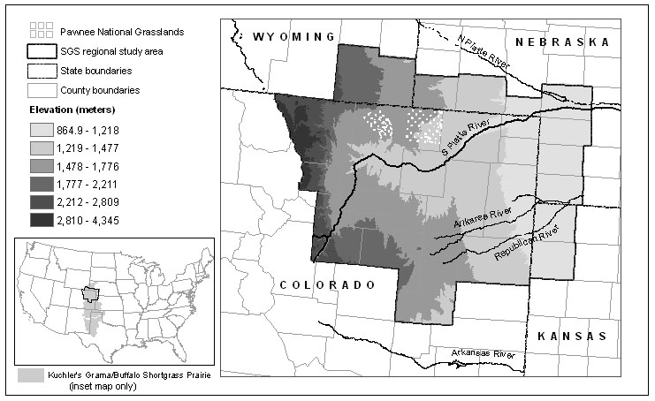
Source: Kuchler, A.W. 1993. Potential Natural Vegetation of the Conterminous United States. Digital Vector Data (digitized from 1:3,186,000 scale map) on an Albers Equal Area Conic polygon network in ARC/INFO format. Corvallis, OR: US - EPA Environmental Research Laboratory. 3 MB in 1 file on 8 - mm tape.
Figure 2. Climate Normal Precipitation (1961-1990) in SGS Counties
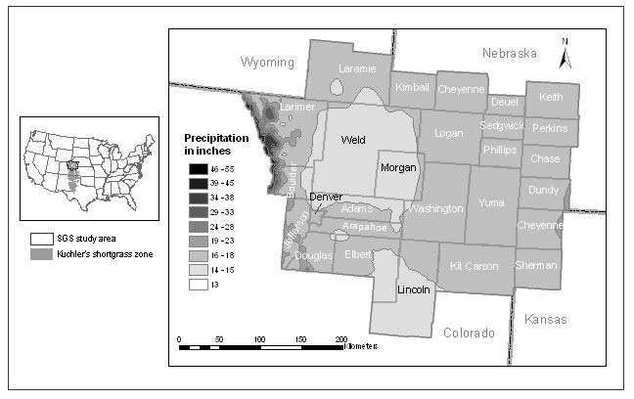

Source: United States Average Annual Precipitation, 1961-1990, USDA - NRCS National Water and Climate Center, Portland, Oregon, PRISM dataset, http://www.ftw.nrcs.usda.gov/prism/prismdata.html
SGS Counties (26) : Weld County, CO; Adams County, CO; Arapahoe County, CO; Morgan County, CO; Washington County, CO; Yuma County, CO; Sedgwick County, CO; Phillips County, CO; Logan County, CO; Larimer County, CO; Boulder County, CO; Jefferson County, CO; Douglas County, CO; Elbert County, CO; Lincoln County, CO; Kit Carson County, CO; Sherman County, KS; Cheyenne County, KS; Dundy County, NE; Chase County, NE; Perkins County, NE; Keith County, NE; Dueul County, NE; Cheyenne County, NE; Kimball County, NE; Laramie County, WY.
Figure 3.
Land Claimed in 1901 and Land Use in 1992.

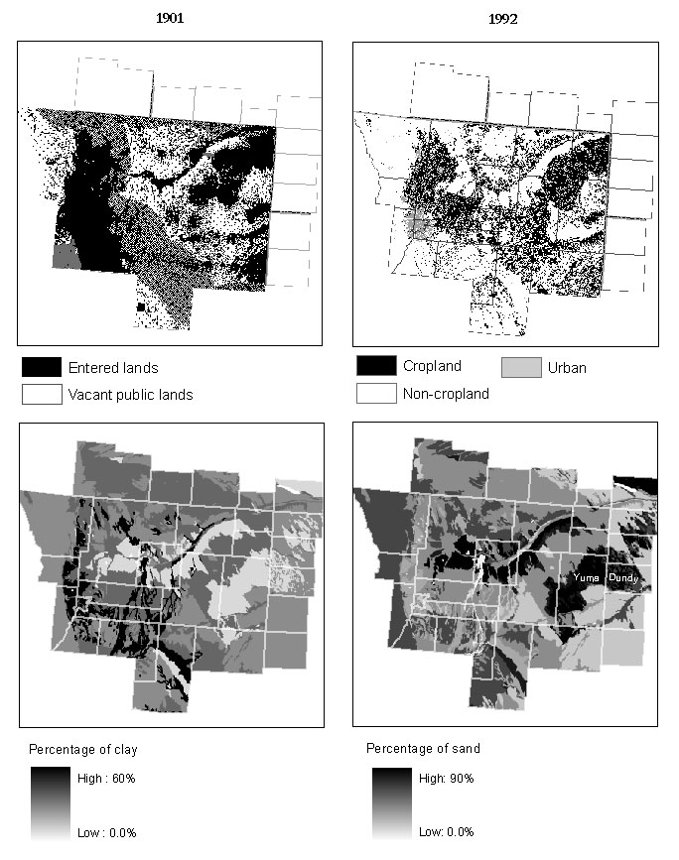

Sources: Entered lands derived from US Bureau of Reclamation, Annual Report 1902, land use derived from USGS National Land Cover Data , 1992, http://landcover.usgs.gov/natllandcover.asp, soil texture is derived from the USDA’s Natural Resources Conservation STATSGO soils database, http://www.ncgc.nrcs.usda.gov/products/datasets/statsgo/.

Figure 4. Land Use in 1938 and Land Cover in 1992, Kit Carson County, Colorado
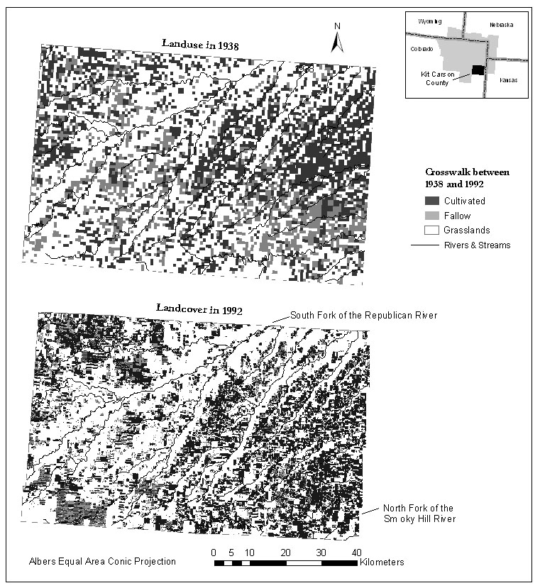

Sources: 1938 land use derived from parcel level map contained in H.N. Watenpaugh, L.A. Brown, L.A. Moorhouse, and R.T. Burdick, “Kit Carson County: A Procedure for Land-Use Classification in the Central High Plains Based on Studies in Kit Carson County, Colo,” August 29, 1941, National Archives and Records Administration Archives, Denver Office, RG 83, Records of the Bureau of Agricultural Economics, Colorado State Office, Box No. 2, Entry 261, 8NN-083-92; and land use is derived from USGS National Land Cover Data , 1992, http://landcover.usgs.gov/natllandcover.asp
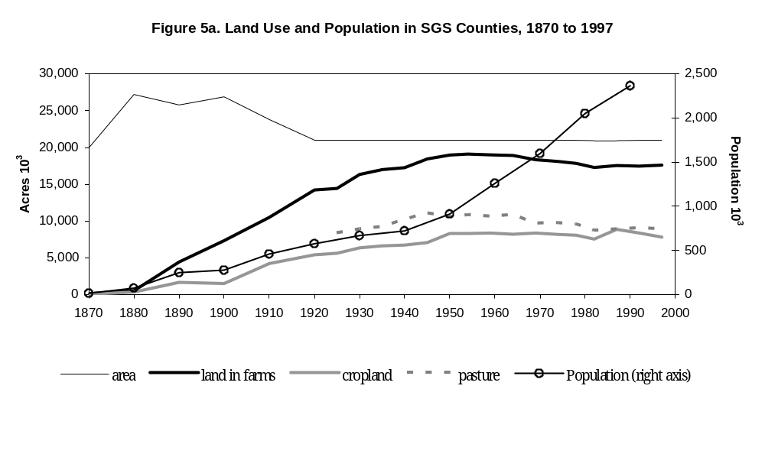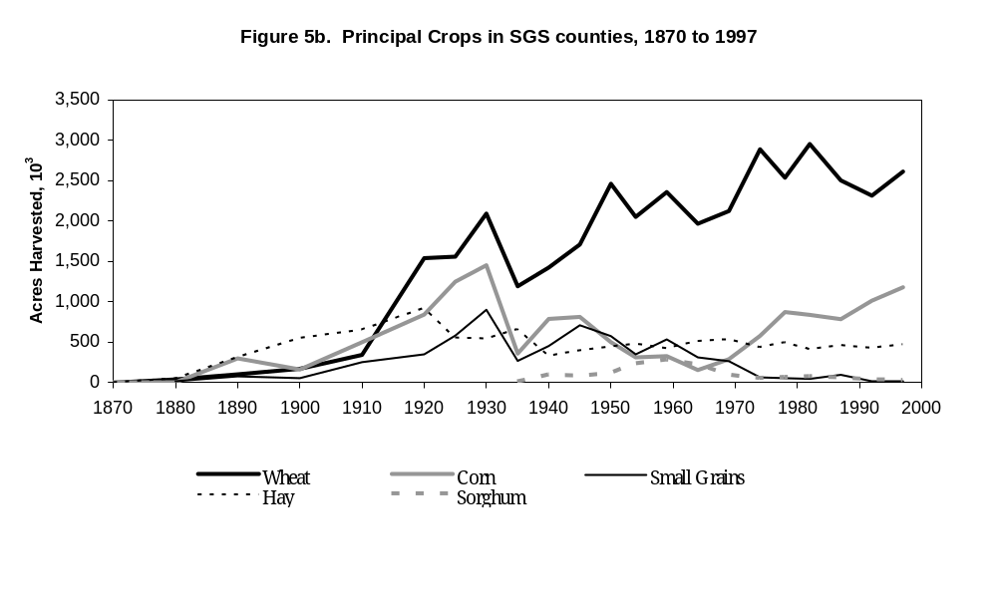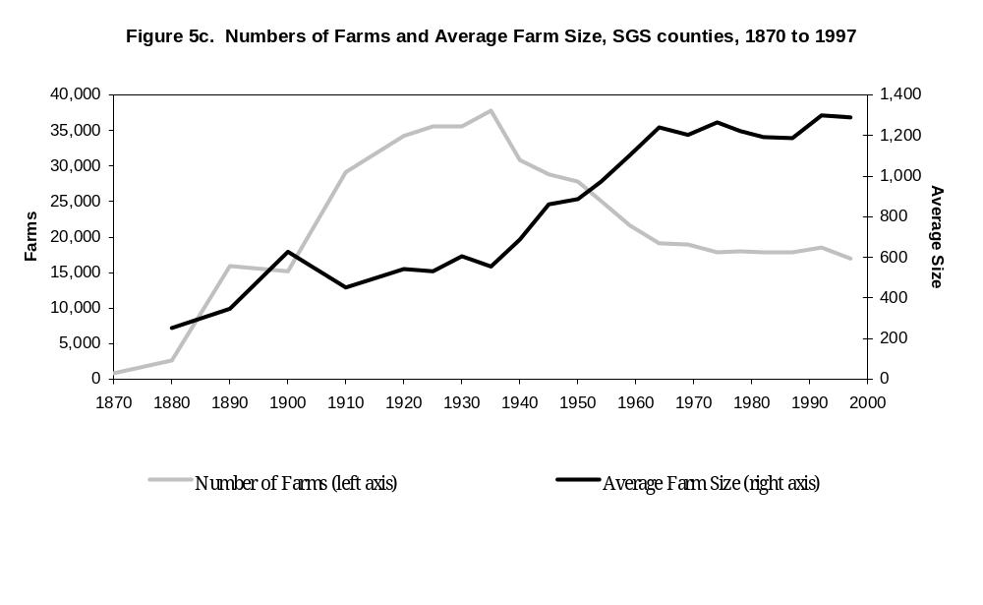
Sources: U.S. Census of Population and Agriculture.
Figure 6. Land Use in South Platte River Basin, 1940 and 1991

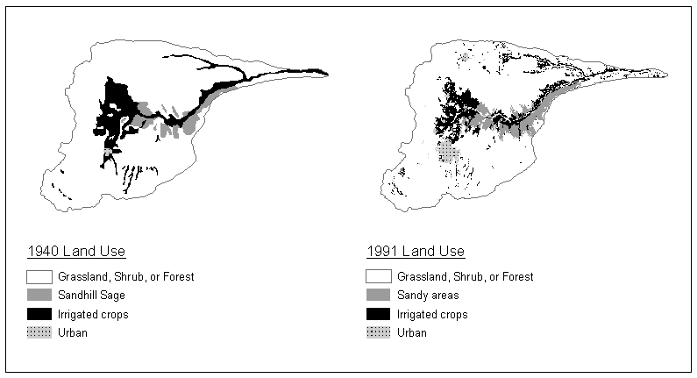

Source: Historical land use from 1940 derived from USDA, Flood Control Survey Report, South Platte River and its Tributaries 1940, and 1991 land use derived from USDA’s National Resources Inventory dataset, 1991, http://www.nrcs.usda.gov/technical/NRI/

Figures 7. Irrigation Wells in the Republican River Basin, 1950 to 1980
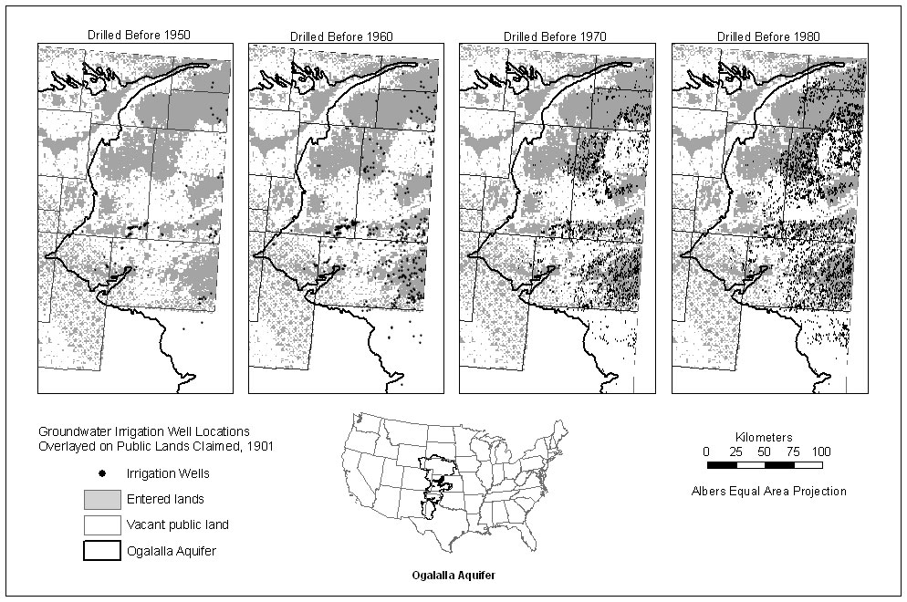

Source: R.G. Borman and R.L. Reed. ‘Location of irrigation wells and application rates for irrigated cropland during 1980 in the northern High Plains of Colorado,’ [map 1:500,000 scale] Reston, Va.: United States Geological Survey, 1984.
Figure 8. Land Ownership in SGS counties, 1998

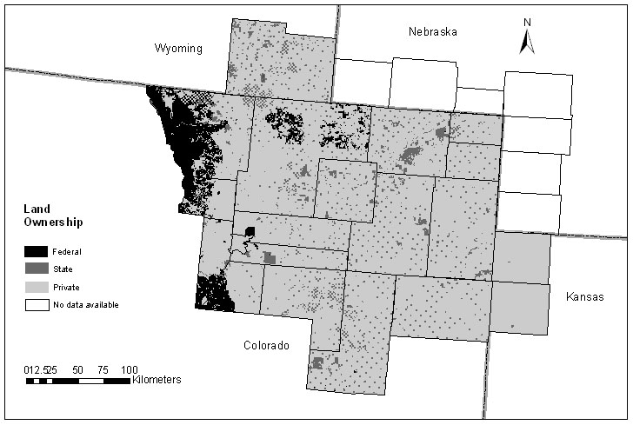

Source: Land ownership data are available in statewide land stewardship ArcInfo coverages (in compressed interchange format) from the USGS GAP analysis program, http://gapanalysis.nbii.gov/index.htm. Land ownership information for Colorado and Wyoming is derived mainly from BLM 1:100,000 Surface Managment Series maps produced between 1991 and 1998. Kansas land ownership information was derived mainly from the state’s Natural Heritage Inventory Program maps and digitized using USGS Digital Raster Graphs at 1:100,000 scale between 1995 and 1998. The GAP stewardship information is intended for evaluating the effects of ownership on wildlife distributions at broad regional scales (>1:100,000).

